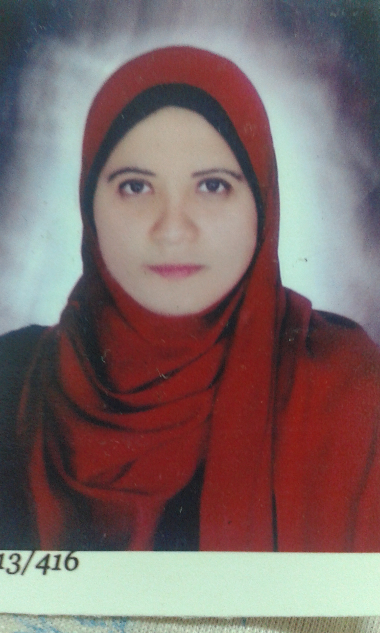
Nancy Mohamed Alaa

Personal information
Full Name : Nancy Mohammed Alaa El-din Mahrous El-Galaly
Date of Birth :5 /11 /1988
Nationality : Egyptian
Contact information
Address : Assiut , ElGeish street
Mobile :02-0100 5079282
E-mail : nancyalaagalaly@gmail.com
Educational information :
(1993-2005) : Salam Language School
(2005-2012): undergraduate student at Faculty of Medicine, Assiut University , I was granted the M.B.B.Ch with general estimate of
" Excellent with honour "
(2014 -2017 ) : Resident of Pediatrics at Assiut University Hospital
(2017-till now) :assistant lecturer at pediatrics department - at Assiut University Hospital

Skills
1-languages : Arabic : native language
English : fluent
French :basic
2- Computer: Power Point ,Word and Internet

Experience :

I am a volunteer at operation smile organization

b-I had attended the following courses :

1- Ethical , law and administrative considerations in medical practice ( Assiut Medical Education and Developmental Center)
2 Infection control ( Assiut Medical Education and Developmental Center )
3- Cardio-pulmonary Resuscitation ( Assiut Medical Education and Developmental Center )
4- Basic Surgical skills ( Assiut Medical Education and Developmental Center )
5- Pre employment Orientation Program ( Assiut Medical Education and Developmental Center )

6-Surgical Firs aids, First Aid of Fractures and burns ( Assiut Medical Education and Developmental Center )
7- writing medical reports ( Assiut Medical Education and -Developmental Center )

8-EVIDENCE BASED MEDICINE ( Assiut Medical Education and -Developmental Center )
9-ADVANCES IN PEDIATRIC CLINICAL NUITRITION _(ASSIUT UNIVERSITY CHILDREN HOSPITAL )
10-pediatric advanced life support (PALS-AHA)
11-NEONATAL RESUSCITATION (ASSIUT UNIVERSITY children HOSPITAL)

12-RESPIRATORY INTENSIVE CARE UNIT (CHEST DEPARTMENT _ASSIUT UNIVERSITY)

